NEW INVESTMENT INCENTIVES SCHEME
IN BRIEF

REPUBLIC OF TURKEY PRIME MINISTRY
INVESTMENT SUPPORT AND PROMOTION AGENCY
OF TURKEY

CONTENTS

1. THE FRAMEWORK OF NEW INVESTMENT INCENTIVES PROGRAM IN TURKEY 3
2. THE SUPPORT MEASURES 4
3. General Investment Incentıves Scheme 6
4. RegIonal Investment IncentIves Scheme 6
5. Large Scale Investment IncentIve Scheme 7
6. StrategIc Investment IncentIve Scheme 8

THE FRAMEWORK OF NEW INVESTMENT INCENTIVES PROGRAM IN TURKEY

The new investment incentives program, which will be effective from the 1st January 2012 comprises 4 different schemes:

- General Investment Incentive Scheme
- Regional Investment Incentive Scheme
- Large Scale Investment Incentive Scheme
- Strategic Investment Incentive Scheme

The support measures to be provided within the frame of those schemes are summarized in the table below:

Support Measures | General Investment Incentive Scheme | Regional Investment Incentive Scheme | Large Scale Investment Incentive Scheme | Strategic Investment Incentive Scheme
VAT Exemption
Customs Duty Exemption
Tax Reduction
Social Security Premium Support
( Employer’s Share)
Income Tax Withholding Support *
Social Security Premium Support
( Employee’s Share) *
Interest Payment Support **
Land Allocation
VAT Refund
* Provided that the investment is made in the Region 6.
** Provided that the investment is made in the Regions 3, 4, 5 or 6 within the frame of the Regional Investment Incentive Scheme

THE SUPPORT MEASURES

VAT Exemption:
In accordance with the measure, VAT is not paid for imported and/or domestically provided machinery and equipment within the scope of the investment encouragement certificate.

Customs Duty Exemption:
Customs duty is not paid for the machinery and equipment provided from abroad (imported) within the scope of the investment encouragement certificate.

Tax Reduction:
Calculation of income or corporate tax with reduced rates until the total value reaches to the amount of contribution to the investment according to envisaged rate of contribution.

Social Security Premium Support (Employer’s Share):
The measure stipulates that for the additional employment created by the investment, employee’s share of social security premium on portions of labor wages corresponding to amount of legal minimum wage, will be covered by the Ministry. The measure is applicable only for the investments to be made in Region 6 within the scope of an investment encouragement certificate.

Income Tax Withholding Allowance:
The measure stipulates that the income tax regarding the additional employment generated by the investment within the scope of the investment encouragement certificate will not be liable to withholding. The measure is applicable only for the investments to be made in Region 6 within the scope of an investment encouragement certificate.

Social Security Premium Support (Employee’s Share):
The measure stipulates that for the additional employment created by the investment, employer’s share of social security premium on portions of labor wages corresponding to amount of legal minimum wage, will be covered by the Ministry.

Interest Payment Support:
Interest payment support, is a financial support instrument, provided for the loans with a term of at least one year obtained within the frame of the investment encouragement certificate. The measure stipulates that a certain portion of the interest /profit share regarding the loan equivalent of at most 70% of the fixed investment amount registered in the certificate will be covered by the Ministry.
Land Allocation:
Refers to allocation of land to the investments with Investment Incentive Certificates in accordance with the rules and principles determined by the Ministry of Finance.

VAT Refund:
VAT collected on the building & construction expenses made within the frame of strategic investments with a fixed investment amount of ¨ 500 million will be rebated.

The following Regional Map and Table of Provinces show classification of provinces for the implementation purpose of the Investment Incentives Program

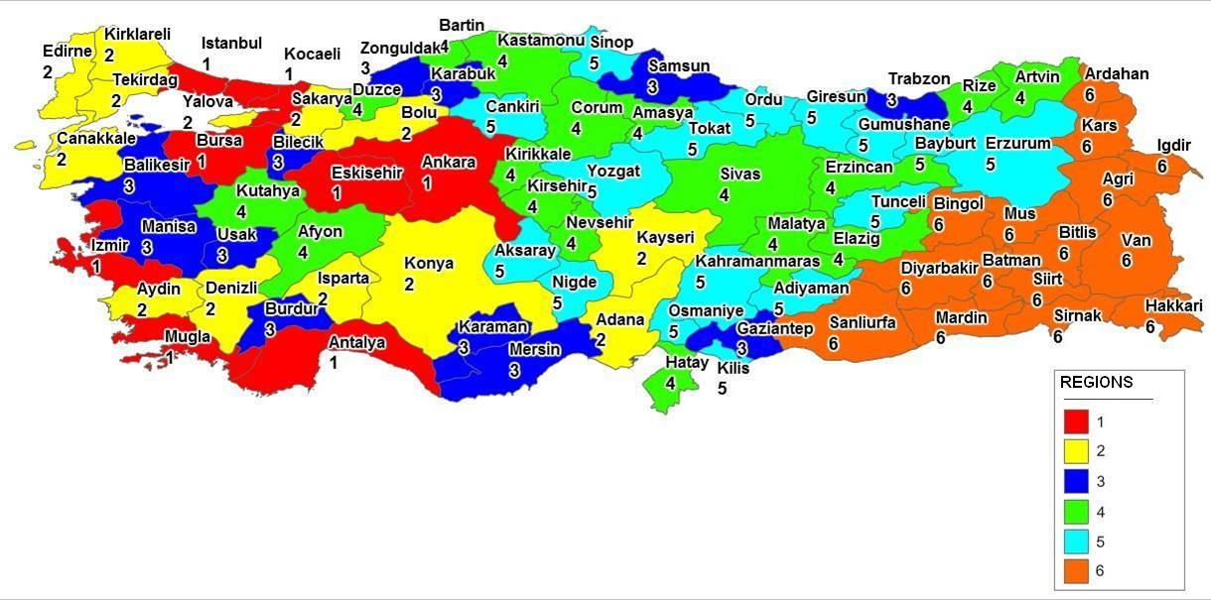

Region 2 Provinces | Region 1  Provinces | Region 3 Provinces | Region 4 Provinces | Region 5 Provinces | Region 6 Provinces
Adana | Ankara | Balıkesir | Afyonkarahisar | Adıyaman | Ağrı
Aydın | Antalya | Bilecik | Amasya | Aksaray | Ardahan
Bolu | Bursa | Burdur | Artvin | Bayburt | Batman
Çanakkale | Eskişehir | Gaziantep | Bartın | Çankırı | Bingöl
Denizli | İstanbul | Karabük | Çorum | Erzurum | Bitlis
Edirne | İzmir | Karaman | Düzce | Giresun | Diyarbakır
Isparta | Kocaeli | Manisa | Elazığ | Gümüşhane | Hakkari
Kayseri | Muğla | Mersin | Erzincan | Kahramanmaraş | Iğdır
Kırklareli |  | Samsun | Hatay | Kilis | Kars
Konya |  | Trabzon | Kastamonu | Niğde | Mardin
Sakarya |  | Uşak | Kırıkkale | Ordu | Muş
Tekirdağ |  | Zonguldak | Kırşehir | Osmaniye | Siirt
Yalova |  |  | Kütahya | Sinop | Şanlıurfa
 |  |  | Malatya | Tokat | Şırnak
 |  |  | Nevşehir | Tunceli | Van
 |  |  | Rize | Yozgat
 |  |  | Sivas
13 PROVINCES | 8  PROVINCES | 12 PROVINCES | 17  PROVINCES | 16  PROVINCES | 15 PROVINCES

General Investment Incentıves Scheme
Regardless of in which Region an investment is made all projects which meet conditions of specific capacity and the following minimum fixed investment amount will be supported within the frame of the General Investment Incentives Scheme. Investment subjects which are excluded from the investment incentives program can not benefit from this scheme.
The amount of minimum fixed investment is ¨1 million in Region 1 and 2 and ¨500 thousand in Regions 3, 4, 5 and 6.

RegIonal Investment IncentIves Scheme
The sectors to be supported in each region are determined in accordance with potentials of the regions and the economies of scale and the intensity of the supports are differentiated in line with the development level of the regions.
The amount of minimum fixed investment is defined separately for each sector and each region, the lowest amount being ¨1 million in Regions 1 and 2, and ¨500 thousand in the remaining Regions.
The terms and rates of supports within the Regional Investment Incentives Scheme are summarized in the Table below:
REGIONAL INVESTMENTS INCENTIVE SCHEME MEASURES
Incentive Measures |  |  | REGIONS
 |  |  | I | II | III | IV | V | VI
VAT Exemption |  |  | YES | YES | YES | YES | YES | YES
Customs Duty Exemption |  |  | YES | YES | YES | YES | YES | YES
Tax Reduction | Rate of Contribution to Investment (%) | Out of OIZ | 15 | 20 | 25 | 30 | 40 | 50
 |  | Within OIZ | 20 | 25 | 30 | 40 | 50 | 55
Social Security Premium Support  (Employer’s Share) | Support Period | Out of OIZ | 2 years | 3 years | 5 years | 6 years | 7 years | 10 years
 |  | Within OIZ | 3 years | 5 years | 6 years | 7 years | 10 years | 12 years
Land Allocation |  |  | YES | YES | YES | YES | YES | YES
Interest Payment Support | Local Loans |  | N/A | N/A | 3 Points | 4 Points | 5 Points | 7 Points
 | Foreign Exchange/  FX denominated loans |  |  |  | 1 Point | 1 Point | 2 Points | 2 Points
Social Security Premium  (Employee’s Share) |  |  | N/A | N/A | N/A | N/A | N/A | 10 years
Income Tax Withholding Support |  |  | N/A | N/A | N/A | N/A | N/A | 10 years
OIZ: Organized Industrial Zones

Specific priority investment subjects to be supported by measures of Region 5 regardless of the Region of the investment:
- Tourism investments in Cultural and Touristic Preservation and Development Regions determined by the Council of Ministers Decree.
- Mining investments
- Railroad and maritime transportation investments
- Specific pharmaceutical investments and defense Industry investments with minimum investment amount of 20 Million TL
- Test facilities, wind tunnel and similar investments made for automotive, space or defense industries
- Primary, Middle and High School investments by private sector

Large Scale Investment IncentIve Scheme
12 investment categories in the table below are supported by the measures of the Large Scale Investment Incentive Scheme:

LARGE SCALE INVESTMENTS
No | Investment Subject | Minimum Investment Amount  (Million TL)
1 | Production of Refined Petroleum Products | 1000
2 | Production of Chemical Products | 200
3 | Harbors and Harbor Services | 200
4 | Automotive OEM and Supply Industries
4-a | Automotive OEM Investments | 200
4-b | Automotive Supply Industries Investments | 50
5 | Railway and Tram Locomotives and/or Railway and Tram Cars | 50
6 | Transit Pipe Line Transportation Services
7 | Electronics
8 | Medical, High Precision and Optical Equipment
9 | Pharmaceuticals
10 | Aircraft and Space Vehicles and/or Parts
11 | Machinery (Including Electrical Machinery and Equipment)
12 | Mining Investments (including metal production)

The terms and rates of supports provided within the Scheme are summarized in the Table below:
LARGE SCALE INVESTMENTS INCENTIVE SCHEME MEASURES
Incentive Measures |  |  | REGIONS
 |  |  | I | II | III | IV | V | VI
VAT Exemption |  |  | YES | YES | YES | YES | YES | YES
Customs Duty Exemption |  |  | YES | YES | YES | YES | YES | YES
Tax Reduction | Rate of Contribution to Investment (%) | Out of OIZ | 25 | 30 | 35 | 40 | 50 | 60
 |  | Within OIZ | 30 | 35 | 40 | 50 | 60 | 65
Social Security Premium Support  (Employer’s Share) | Support Period | Out of OIZ | 2 years | 3 years | 5 years | 6 years | 7 years | 10 years
 |  | Within OIZ | 3 years | 5 years | 6 years | 7 years | 10 years | 12 years
Land Allocation |  |  | YES | YES | YES | YES | YES | YES
Social Security Premium  (Employee’s Share) |  |  | N/A | N/A | N/A | N/A | N/A | 10 years
Income Tax Withholding Support |  |  | N/A | N/A | N/A | N/A | N/A | 10 years
OIZ: Organized Industrial Zones

The following categories of investments within the Regional and Large Scale Investment Incentives Schemes will be supported by more beneficial one level up regional rates and terms :

- Investments in Organized Industrial Zones
- Joint investments to be made by at least 5 companies operating in the same sector with the purpose of integrating these companies horizontally or vertically to this joint investment
- Investments made to produce products developed by an R&D Project which is supported by TÜBİTAK

StrategIc Investment IncentIve Scheme
Investments meeting the criteria below are supported within the frame of the Strategic Investment Incentive Scheme:
- to be made for production of intermediate and final goods with high import dependence and of these goods more than 50% are supplied by imports
- to have a minimum investment amount of ¨50 Million,
- to create minimum 40% value added
- to have an import of at least $50 Million for goods to be produced in the last one year period (This condition is not applicable to goods with no domestic production)

STRATEGIC INVESTMENTS INCENTIVE SCHEME MEASURES
Incentive Measures |  | REGIONS
 |  | I | II | III | IV | V | VI
VAT Exemption |  | YES
Customs Duty Exemption |  | YES
Tax Reduction | Rate of Contribution to Investment (%) | 50
Social Security Premium Support  (Employer’s Share) | Support Period | 7 Years (10 years for 6th region)
Land Allocation |  | YES
Interest Payment Support | Local Loans | 5 points
 | Foreign Exchange /FX denominated loans | 2 points
Social Security Premium  (Employee’s Share) |  | 10 years (only for investments in the Region 6)
Income Tax Withholding Support |  | 10 years (only for investments in the Region 6)
VAT Refund |  | YES

