Fossil Fuels in Turkey

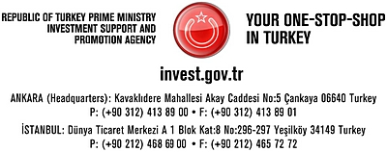

- Fossil fuel potential/production in Turkey

OIL

According to the General Directorate of Petroleum Affairs, Turkey has around 285 million barrels of remaining recoverable oil reserves by the end of 2008, while having 6.7 billion barrels of proven and probable-possible oil reserves in total.

OIL Production&Consumption of Turkey | 2004 | 2005 | 2006 | 2007 | 2008
Crude Oil Production (Tons)* | 2,275,530 | 2,281,131 | 2,175,668 | 2,134,175 | 2,160,067
Civilian Consumption of the Petroleum Products (Tons)* | 30,627,656 | 29,985,588 | 29,908,906 | 30,942,965 | 27,026,509
*Source: General Directorate of Petroleum Affairs

CRUDE OIL RESERVES OF TURKEY BY THE END OF 2008
Original oil in place |  | Recoverable oil |  | Cumulative production |  | Remaining recoverable oil
Bbls | M.Tons | Bbls | M.Tons | Bbls | M.Tons | Bbls | M.Tons
6,742,331,154 | 986,768,959 | 1,206,286,518 | 172,347,038 | 921,827,820 | 130,670,073 | 284,458,698 | 41,676,965
Source: General Directorate of Petroleum Affairs

CRUDE OIL AND PETROLEUM PRODUCTS MOVEMENTS OF TURKEY (METRIC TONS), 2008
Crude Oil Production | Crude Oil Imports | Total | Processed Crude Oil | Obtained Products | Imported Products | Exported Products | Civilian Consumption
2,160,067 | 21,724,235 | 23,884,302 | 24,008,904 | 24,345,316 | 11,493,185* | 7,559,497 | 27,026,509*
*To be revised
Source: General Directorate of Petroleum Affairs

Oil exploration and production activities are dominated by the Turkish Petroleum Corporation (TPAO). In 2007, TPAO produced 71% of Turkey’s overall crude output, with Batman, Adiyaman and Thrace regions accounting for around 68%, 31% and 1% of that proportion respectively. The principal government body charged with monitoring the oil sector is the Ministry of Energy and Natural Resources (MENR), which is the key decision-making body that approves new projects along with the State Planning Organization (DPT).

NATURAL GAS

Turkey has around 6.8 billion cubic meter (m³) of proven natural gas reserves which is yet to be recovered. Turkey is a growing consumer of natural gas in its own right, with consumption having increased significantly over the last decade. A huge gap between consumption and production creates highly profitable opportunities for energy investors. Historically, much of Turkey’s natural gas production occurred at sites where crude oil was also produced. Over the last decade, however, several non-associated natural gas fields have been discovered. The largest non-associated natural gas find is Marmara Kuzey, an offshore field that came on stream in 1997 located in the Thrace-Gallipoli Basin of the Sea of Marmara. Turkey’s small natural gas production is carried out primarily by the Turkish Petroleum Corporation (TPAO, www.tpao.gov.tr), which produced approximately 421 million m³ in 2007, while other companies produced 472 million m³ of natural gas in the same year.

Natural Gas Production&Consumption of Turkey | 2004 | 2005 | 2006 | 2007 | 2008
Natural Gas Production (Million m³)* | 707 | 896 | 907 | 893 | 1,014
Natural Gas Consumption (Million m³) ** | 22,443 | 27,375 | 31,183 | 36,599 | 37,178
*Source: General Directorate of Petroleum Affairs, www.pigm.gov.tr
**Source: EIA, www.eia.doe.gov

NATURAL GAS RESERVES OF TURKEY BY THE END OF 2008 (M³)
Original gas in place (*) | Recoverable gas | Cumulative production | Remaining recoverable gas
22,975,790,189 | 17,400,096,091 | 10,573,786,794 | 6,826,309,297
Source: General Directorate of Petroleum Affairs, www.pigm.gov.tr

Prior to 2001, Turkey’s natural gas market and infrastructure were almost entirely dominated by state-owned BOTAS. In May 2001, Turkey enacted a new Natural Gas Market Law with the intent to liberalize the natural gas sector, encourage foreign investment in energy infrastructure, and harmonize its energy policy with that of the EU. Among other things, the law aimed to abolish the monopoly, separating the company into units for natural gas import, transport, storage, and distribution by 2009. Consequently, the law has paved the way for privatization of the natural gas market, various components of which have already been privatized. Turkey’s Energy Market Regulatory Authority (EMRA) is responsible for implementing the Natural Gas Market Law, and also now sets natural gas prices in Turkey.
COAL
Total hard coal reserves of Turkey are 1.3 billion tons, 560 tons of which are proved reserves as of 2009. The volume of lignite reserves is 12.3 billion tons. Lignite reserves are available in 37 cities and in every geographical region in Turkey. 21% of the lignite reserves are operated by the public institution General Directorate of the Turkish Coal (www.tki.gov.tr), and the rest is operated by two other public institutions, Electricity Production Company (www.euas.gov.tr) and General Directorate of Mineral Research and Exploration (www.mta.gov.tr), and the private sector. Hard coal reserves are in the city of Zonguldak and operated by the public institution Turkish Hard Coal Enterprises (www.taskomuru.gov.tr). In 2008, 84 million tons of lignite and 1.3 million tons of hard coal were produced in Turkey.

The coal potential of Turkey has not been ascertained yet. Most of the lignite reserves were found between 1976 and 1990. After that period reserve development surveys and drilling operations have not been in an extensive scale.

- Fossil fuel exploration activities (current and future projects)

Exploration Activities

The majority of Turkey’s oil reserves are located in southeastern part of the country and in the Thrace region in the northwest. Exploration licenses are granted by the General Directorate of Petroleum Affairs, while other licenses are granted by the Energy Market Regulation Authority.
- Totally 429 exploration licenses covering an area of 383 000 km2 hectares have been granted to 48 oil companies.
- 148 licenses (34%) have been granted to Turkish Petroleum Company (TPAO).
- There are 24 foreign and 24 domestic companies conducting exploration activities.
- There has been a 5% increase in the number of exploration licences over the previous year.
- There are totally 78 leases, 48 of which belong to TPAO.
- The leading exploration and production companies are TPAO, Perenco, Toredor, Aladdin Middle East Joint Venture, Thrace Basin, Amity Oil, Merty Energy Joint Venture, Petroleum & Dorchester.
- In Turkey, totally 107 oil fields, 4 CO2 fields and 38 gas fields have been discovered till the end of 2008.

PETROLEUM Exploration Fields in Turkey

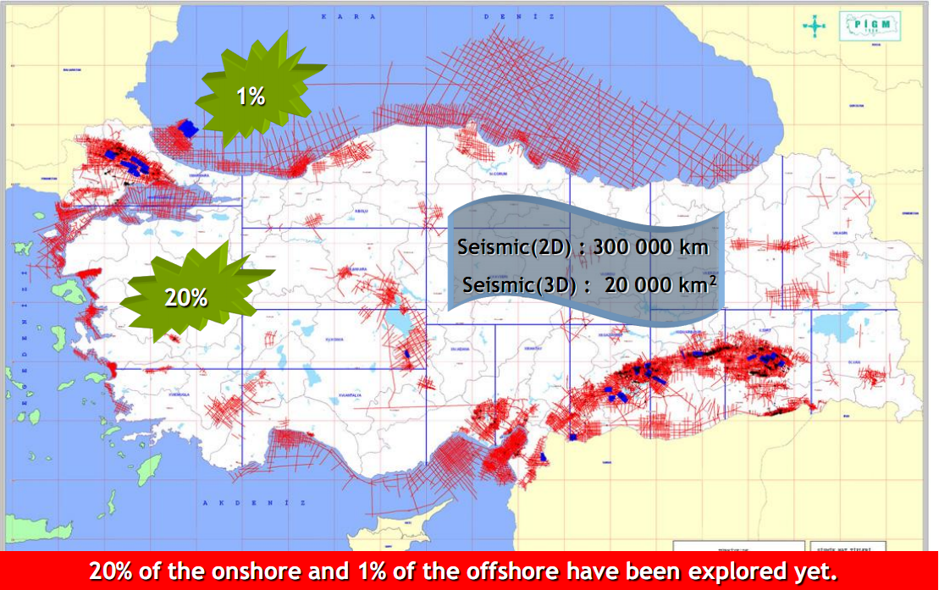
Source: General Directorate of Petroleum Affairs, www.pigm.gov.tr

Companies | Exploration , extension and geological test wells
 | Drilled in 2008 |  | Total by the end of 2008
 | Number | Footage (m.) | Number | Footage (m.)
T.P.A.O. | 31 | 75,866 | 1,180 | 2,727,356
M.T.A. |  |  | 89 | 111,305
Other domestic companies | 17 | 18,313 | 53 | 44,936
Foreign companies | 38 | 48,430 | 601 | 1,012,387
Domestic+Foreign co.s joint ventures | 10 | 14,347 | 177 | 386,282
Total | 96 | 156,956 | 2,100 | 4,282,266
Source: General Directorate of Petroleum Affairs, www.pigm.gov.tr

Joint Domestic Exploration, Development and Production Activities of TPAO
Onshore
Companies | Fields
TPAO-Chevron-NVT Perenco | Cudi - Silopi (Sirnak)
TPAO-Toreador | Cendere (Adiyaman)
TPAO-NVT Perenco | South Eastern Anatolia Region
TPAO- Amity Oil | Thrace Basin
Offshore
TPAO – Toreador – Stratic | Akcakoca (Duzce)
TPAO - Petrobras | Kirklareli, Sinop
TPAO – Exxonmobil | Kastamonu, Samsun
Source: TPAO, www.tpao.gov.tr

Subsidies in the Upstream Sector

- In order to encourage new discoveries, in addition to royalties 10 % deduction is made for the fields that were discovered before 1980,
- Material and equipment procurements which are used in oil activities are exempted from customs and imports taxes,
- Exploration activities are exempted from VAT,
- The exploration and production activities are exempted from Private Consumption Tax for fuel and specific vehicles,
- In order to encourage exploration and production there are additional deductions in corporate tax.
- The foreign exploration companies have the right to transfer their capital imported for exploration investments when they started production.

- Current and future public-private sector projects for fossil fuel storing/transfer/transmission

Oil Pipelines
Turkey, which lies between the energy-rich countries of the Caspian Sea and Persian Gulf regions and net energy importing countries in continental Europe, is increasingly important for oil transit. Turkey has established or considered a number of pipeline projects that would transport oil into Turkey without relying on the crowded Bosporus Straits. In the oil transport sector, Petroleum Pipelines Co. (BOTAS, www.botas.gov.tr) owns and operates virtually the entire pipeline network in Turkey.

Int’l Oil Pipelines | Route | Length | Diameter (inch) | Capacity | Cost ($) | Source | Status
BTC | Baku -Tbilisi- Ceyhan | 1769 km | 46"/42"/34" | 1 ml bbl/d | 4,80 bl | Azerbaijan Kazakhstan | In operation
Iraq -Turkey | Kirkuk - Yumurtalik | 1876 km | 46"/40" | 1,37 ml bbl/d | - | Iraq | In operation
Samsun - Ceyhan | Samsun - Sivas - Ceyhan | 551 km | 48"/42" | 1,35 ml bbl/d | 2 bl | Caspian Region, Russia | Under Construction
Source: MENR, www.enerji.gov.tr

Crude Oil Transportation (Thousand Barrels / Year)
 | IRAK-TURKEY | CEYHAN-KIRIKKALE | BATMAN-DÖRTYOL | ŞELMO-BATMAN | BTC (BIL)
2006 | 12.930 | 27.381 | 10.822 | 535 | 57
2007 | 39.833 | 23.003 | 10.147 | 507 | 210.352
2008 | 135.522 | 21.427 | 11.060 | - | 264.092
Source: BOTAS, www.botas.gov.tr

Natural Gas Pipelines
In addition to Turkey’s energy demand, although Turkey does not have sizeable reserves, it is an important energy transit country for the transportation of natural gas from the main sources to the main consumer markets, namely from Russia, Middle and Central Asia to Europe. Turkey has an extensive network of natural gas pipelines connecting markets both domestically and internationally.
Domestic Network of Pipelines
Turkey’s growing natural gas demand has led BOTAS to substantially increase the country’s natural gas transport infrastructure. Turkey’s domestic pipeline network has also grown alongside the country’s growing international pipeline connections.
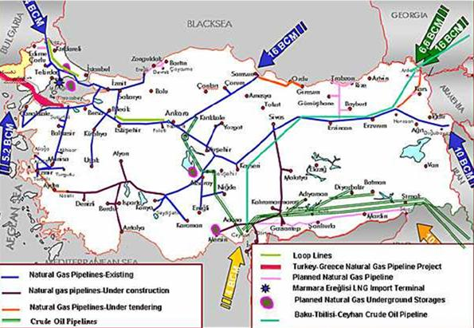
Source: BOTAS (BCM: billion cubic meters)

International Network of Pipelines
Turkey has several important international pipeline links that bring natural gas to Turkey for domestic consumption, but that might also build upon Turkey’s emerging role as an energy transit country.

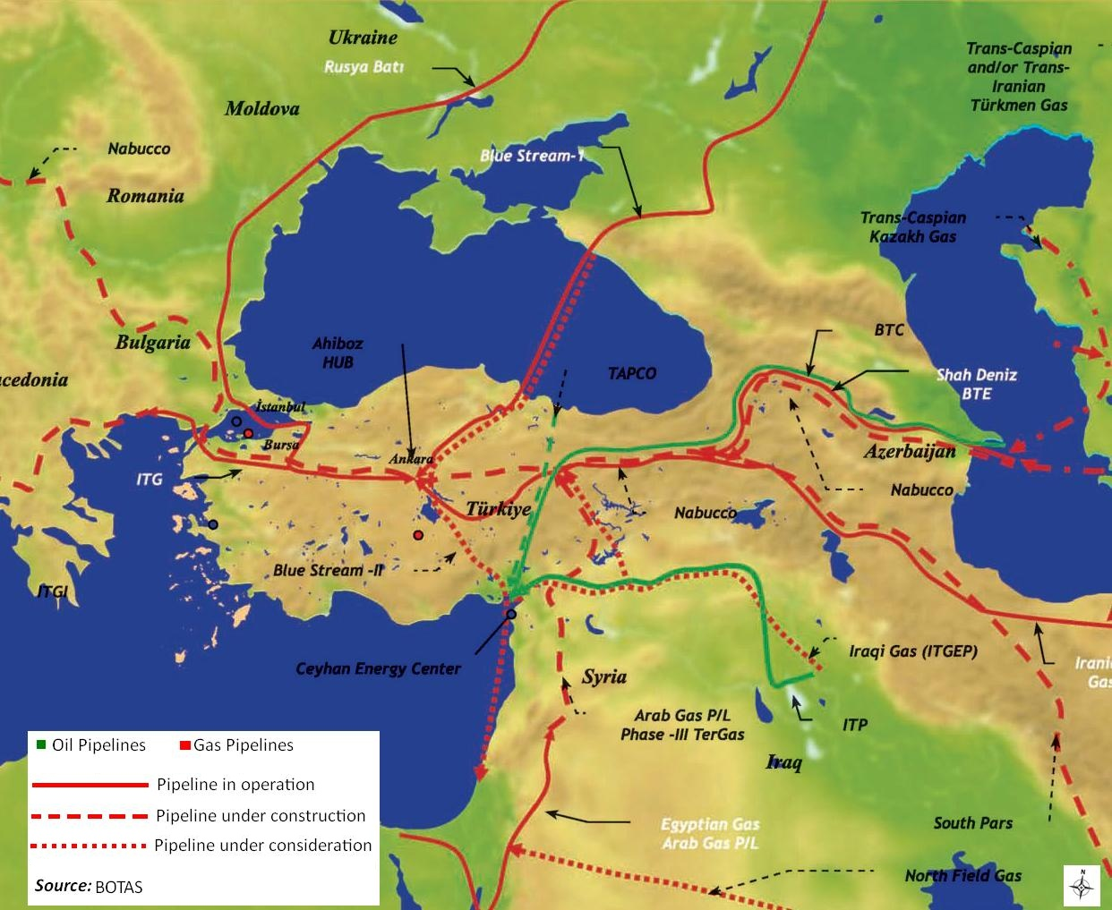

Major Int’l Natural Gas Pipelines | Route | Length (km) | Capacity (m³/y) | Source | Status
Blue Stream | Russia-Turkey | 1213 | 16 | Russia | In operation
Iran-Turkey | Iran | 1210 | 14 | Iran | In operation
Turkey - Greece - Italy | Karacabey-Komotini-Otranto | 808 | 11,6 | Azerbaijan | In operation
Baku-Tbilisi-Erzurum (BTE)  (South Caucus Pipeline SCP) | Azerbaijan-Georgia-Turkey | 690 | 8,8 | Azerbaijan | In operation
Trans-Arab Pipeline | Egypt-Jordan-Syria-Turkey | 1236 | 10 | Egypt | Project Preparation Stage
Iraq-Turkiye | Iraq - Turkey | 1160 | 10 | Iraq | Project Preparation Stage
Trans-Adriatic | Turkey-Greece-Albania | 533 | 24 | Iran-Shah Deniz | Project Preparation Stage
Nabucco | Turkey-Bulgaria --Romania-Hungary -Austria | 3282 | 30 | Caspian Region - Iran-Iraq-Egypt | Project Preparation Stage
Source: MENR, www.enerji.gov.tr

- Industries processing fossil fuels and forthcoming public-private sector projects

The downstream oil refining and storage sector is dominated by Turkish Petroleum Refineries Co. (TUPRAS, www.tupras.com.tr), which controls Turkey’s entire refining activities. TUPRAS is the leading refiner in Turkey, with a 542 thousands bbl/d (28.1 million ton/year) of crude oil refinery capacity. It operates three large refining complexes at Aliaga near Izmir (212,863 bbl/d capacity), Izmit (212,863 bbl/d), and Kirikkale (96,301 bbl/d) as well as a smaller facility at Batman (21,186 bbl/d). A joint venture of Calik Energy and Indian Oil Company (IOC) has been granted refinery license in December 2007; the joint venture is called “Dogu Akdeniz Petrokimya ve Rafineri Sanayi ve Ticaret Anonim Sirketi” which proposed the construction of a 300,000-bbl/d refining and petrochemical complex at Ceyhan, at a reported cost of $4.5 billion.

Several companies are considering new refinery projects in Turkey, reflecting the country’s emerging status as a regional energy hub. Petrol Ofisi A.S. (POAS) has proposed the building of a $2 billion, 200,000-bbl/d facility in Ceyhan. Russia’s Lukoil is currently drafting a feasibility study for a possible plant along Turkey’s Black Sea coast. Although the plans are tentative, media reports suggest that the site would be either Samsun or Zonguldak, and have a capacity between 160,000 and 200,000 bbl/d. Socar & Turcas Rafineri A.S. has also a refinery project planned to be built in the Alaağa facility of Petkim (www.petkim.com.tr), and the license application for this investment is at the evaluation stage of the Energy Market Regulatory Authority.

Production of Tupras Refineries (thousand tons)
Products | 2007 | 2008
LPG | 761 | 769
Naphta | 879 | 559
Gasoline | 3969 | 4420
Jet Fuel/Kerosene | 2588 | 2829
High Sulfur Diesel | 4904 | 4075
Diesel | 2203 | 2546
Mid-Distillate | 9695 | 9450
Fuel Oil | 5432 | 4765
Asphalt | 2286 | 2242
Lubricant Base Oil | 294 | 264
Other | 677 | 312
Total | 23994 | 22780
Source: TUPRAS, www.tupras.com.tr

Petkim (www.petkim.com.tr) is the leading player in the Turkish petrochemicals industry with a total production capacity of 1.9 million tons/year. The company is the only producer in the field of basic petrochemicals and the largest manufacturer of intermediary products and thermoplastics in Turkey.

Domestic Consumption, 000 tons | 2008
Thermoplastics | 3126
Fiber Raw Materials | 609
Rubber Raw Materials | 294
Others | 180
Total | 4209
Source: Petkim, www.petkim.com.tr

Petkim Production, 000 tons | 2007 | 2008
Ethylene | -2 | 3
Thermoplastics | 668 | 642
Fiber raw materials | 179 | 179
Others | 539 | 586
Total | 1383 | 1409
Source: Petkim, www.petkim.com.tr

Source: TPAO, www.tpao.gov.tr
Source: General Directorate of the Turkish Coal (www.tki.gov.tr), 2009
Source: General Directorate of Petroleum Affairs, www.pigm.gov.tr
Source: General Directorate of Petroleum Affairs, www.pigm.gov.tr

